Improvement to COVID-19 Detector using Chest

Radiographs with Deep Deep Transfer Learning and Capsule Networks

Sirish Prabakar Dane Jew

# Abstract

*Machine Learning and Deep Learning are increasingly in demand as tools for detecting the effects of global pandemic diseases. Currently the disease, COVID-19, which is caused by the novel coronavirus is ravaging the world, especially the United States. Currently COVID-19 is primarily detected by lab testing, specifically by polymerase chain reaction or PCR. This method tends to be slow, complex, at times inaccurate, and very scarce. The motivation to use Learning tools come from the fact that analysis of chest radiography imaging, including Chest X-rays and CT scans, seems to show more promise. Visual analysis can be faster than lab results. This is an advantage due to urgency in developing many different detection techniques to help mitigate the disaster caused by the active pandemic. One such proposed system is called COVID-Net which is based on a modified CNN model and transfer learning to perform the classification of COVID-19 [8]. This is a raw system that had a 92.4% accuracy. Our approach focuses on using capsule network for the same purpose and we outperformed the proposed model by using capsule network along with pre-training with X-ray images. Capsule networks are better suited for image classification with image features having different orientations. They also can be trained on much lower number of total params while producing appreciable performance.*

# 1. Introduction

The goal of the proposed project is to implement a system that analyzes chest radiography images, including X-rays and CT scans to predict the presence of COVID-19. The model is an an improvement of COVID-Net. COVID-Net is a deep learning system proposed by Linda Wang and Alexander Wong [8]. It is essentially an augmentation of a simple CNN model used to analyze a dataset consisting of chest radiography images. The dataset, which comes from multiple open sources repositories, contains both X-ray and CT images. The images contain 3 classes of images, Normal, Non-COVID (Pneumonia), and COVID-19 infections [5][9]. When trained and tested, the system was able to predict COVID-19 infected images at a 92.4% accuracy.

An improvement on COVID-Net was proposed by another paper written by Parnian Afshar, Shahin Heidarian et al. Capsule Networks allow systems to capture spatial information, i.e. identification of objects or features by using routing by agreement [6].The model and the idea of incorporating Capsule network as an alternative to generic CNN model was adopted from this reference[6]. The reasoning behind using capsule networks is that in previous studies, it works very well for other types of radiography images, such as brain tumors [2][3].

# 2. Problem Formulation

The dataset is organized as a collection of images. In Python this would be a dataset with Numpy arrays of (224 x 224 x 3). The labels are binary (0,1) to indicate whether or not the image indicates a negative or positive COVID-19 prediction. Due to the scarcity of publicly available repositories for chest radiography images, multiple sources were needed to build the dataset [5][9][10]. The same dataset will be applied to the COVID-Caps and the proposed system.

The pre-training dataset consists of 94323 frontal view chest X-ray images for common thorax diseases. This dataset is extracted from the NIH Chest X-ray dataset available online for public access here[5][9]. Chest X-ray14 dataset originally contains 112120 X-ray images for 14 thorax abnormalities. This dataset also contains normal cases without specific findings in their corresponding images[10].

To reduce the number of categories, we classified these 15 groups into 5 categories based on the underlying relations between the abnormalities in each disease. The first four groups are dedicated to No findings, Tumors, Pleural diseases, and Lung infections categories. The fifth group encompasses other images without specific relations with the first four groups. We then removed 17797 cases with multiple labels (appeared in more than one category) to reduce the complexity and downscaled all images from (1024,1024) to (224,224). After complete preprocessing the input will be reduced to 3 classes, Normal, Pneumonia (Non-Covid-19), and COVID-19.

Such large data could not be easily stored in one numpy array. Due to this we had to save them into small npy.files and concatenate them on google colab PRO. Once this was done we could load the final versions of the numpy arrays right before training.

# 3. System Design

The project is an implementation of both the COVID-Caps system and the proposed Transfer Learning system with Capsule Networks.

## 3.1 System Architecture

### 3.1.1 Comparison of the COVID-Caps vs. Transfer Learning with Capsule Networks Architecture.

**3.1.2 COVID-CAPSULE.**

A CNN model is modified to perform an optimized analysis of the chest radiography images. In addition to this a Capsule Network was added to determine the spatial information needed to identify various features of the image for classification.

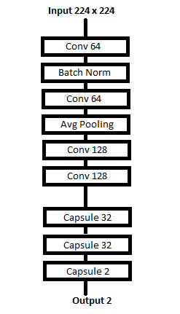

Figure #. COVID-Caps Architecture.

**3.1.3 Proposed Transfer Learning Architecture.** This is the proposed system for this project. This model uses the ResNet152v2 Transfer Learning model. In addition to the ResNet layer, other layers were added for tuning.

# 

Figure #. Proposed Transfer Learning Architecture.

# 4. Experimental Evaluation

Both models for this project are classification models. The idea is those images that are identified as having COVID-19 is “COVID-19 Positive” and all other cases(non-covid and normal) are classified as Negative.

## 4.1 Methodology

In short we aim to achieve 2 tasks. One is to compare Capsule network performance with pre-training to Transfer learning architecture for same dataset. Second is to use capsule network architecture to produce same performance as the performance achieved by the proposed model in the research paper mentioned, if not beat it.

The data required for both models needed to be separated into Training and Testing data, as is typical with most neural network models. Our main focus is on the dataset proposed in the research paper and to implement Capsule network with this dataset.. However we have also created another dataset with high-quality images and high number of covid images. We designed a transfer learning model for this dataset. This is just for comparison of Capsule Network vs CNN.

The parameter tuning used for the COVID-Capsule system for the most part was very basic. The activation functions for most of the layers used RELU. The Adam optimizer was also used for the compiler. The Batch Normalization used momentums of 0.99 while epsilon was set to 0.001. All Convolution layer kernels were set to (3x3). This system was run at 100 epochs.

The Transfer Learning model on the other hand used fully connected dense layers with one of them use RELU as an activation function and the final layer using Softmax. Average pooling was used as the pooling layer. The model was also set to non-trainable in all layers.

In order to compare the two systems, a series of metrics is required. They are accuracy, precision, specificity, sensitivity, and the F1 score. The ROC curve is also appropriate for this comparison.

## 4.1 Results

Using the same dataset for both models it is possible to get a clear picture as to which model performs better at identifying which chest radiograph is COVID-19 positive. The scores are compared by accuracy, precision, specificity, sensitivity, and F1-score.

**4.1.1. COVID-Capsule Training and Testing on 2nd dataset.**

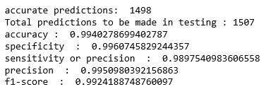Figure #. Precision of the COVID-Caps model.

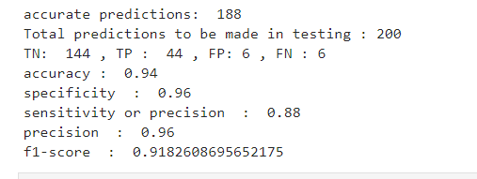

**4.1.1. Transfer learning model- Training and Testing on 2nd dataset.**

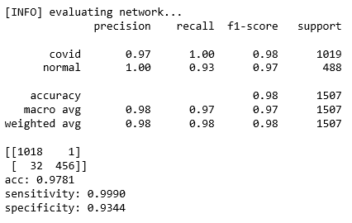

Figure #. Precision of the Transfer Learning Model.

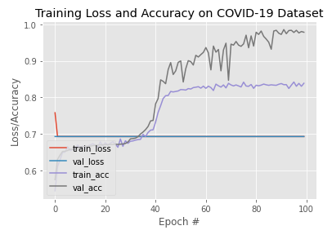

These evalutions were performed on a second dataset which produced high accuracy in both cases. This was just for comparison of Capsule vs CNN performance. Later main dataset which is proposed in paper will be used.

Here it is quite convincing that capsule network outperforms traditional methods of transfer learning with pre-trained models. Keeping this in mind we will Focus on using Capsule network to compete with proposed model in the paper, the main dataset proposed in the paper will be used for comparison

**4.2 Capsule network performance on Main dataset with no pre-training**

Figure #. Training Loss and Accuracy on COVID-19 Dataset.



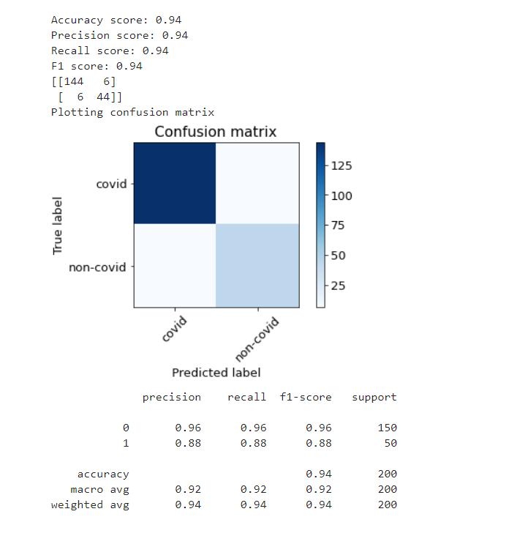

# Performance comparison with proposed results:

Performance of COVID-net in research paper:

Total params: 117,000,000  
Precision for(COVID)- 96.4  
Sensitivity(CVOID cases)- 87.1  
accuracy - 92.4

Our model’s performance:

Total params: 295,488  
Precision for(COVID)- 96.0  
Sensitivity(CVOID cases)- 88.0  
accuracy - 94.0

Except for the Precision parameter we slightly did better than the proposed model in the other categories. Here the precision and sensitivity is considered only for detection of COVID positive cases. Since the proposed model has 3 classes covid, non-covid and normal and ours has only 2 classes non-covid (which includes normal) and COVID. For this reason, performance parameters of only COVID cases is considered. Also number of total parameters is drastically reduced from 117 million to 295k with this approach. This is a big advantage if the task at hand requires considerable amount of params during training.

Inference:

Clearly sensitivity is lower in both cases. Sensitivity is directly proportional to True Positive cases. Since the data for COVID cases is much smaller than non covid cases, both models were not able to perform well in the sensitivity category. The other performance parameters are doing well due to large volumes of non covid data. This gives the model enough number of training inputs with wide variety making it better prepared for predicting new data. Finally the test data was limited to two hundred instances. We could have obtained better results with a more proportional sized testing data however this was how it was implemented in the paper at reference, so we went along with it.

# 5. Related Work

The proposed model in [8] uses a transfer learning with CNN and COVID-NET/COVID-RESNET. The dataset used in the research paper will be the same dataset we will be using. However the model used to train is what will differ in our approach. Our architecture uses elements from both COVID-NET as well as COVID-Capsule with modifications to get the best performance. We will be using Capsule network to do the classification and we will refrain from using ready made models like COVID-NET/ResNetV2 as transfer learning. Instead we will pre-train our model with 94 thousand X-ray images of patients of various lung diseases. The idea behind this is to train our model with only X-ray images so that the image feature detection is highly applicable in detecting COVID-19 while training and testing with the proposed dataset. We believe this combined with the capsule network’s performance advantage compared to CNN, helped us develop a stronger model with better performance.

# 6. Conclusion

We were able to obtain appreciable performance with capsule network. Our future work will focus on using real time data augmentation and making use of better dataset to build a strong DL model to handle such classification with high performance.

Overall we were very satisfied with our approach and end result. We were trying out something new and we had no idea whether it would work or not. Eventually we were able to unfold our mistakes, make improvements and produce an appreciable amount of progress. Keeping in mind that we would be commended if we put in our best efforts we worked to make progress rather than just trying to get the end result. I feel this made the whole learning experience effective and fun too.

# 7. Work Division

|  |  |  |
| --- | --- | --- |
| **Research** | | |
|  |  |  |
|  | Work Pct |  |
| Sirish Prabakar | 80% |  |
| Dane Jew | 20% |  |
|  |  |  |

|  |  |  |
| --- | --- | --- |
| **Coding** | | |
|  | Work Pct |  |
| Sirish Prabakar | 60% |  |
| Dane Jew | 40% |  |
|  |  |  |

|  |  |  |
| --- | --- | --- |
| **Documentation** | | |
|  | Work Pct |  |
| Sirish Prabakar | 40% |  |
| Dane Jew | 60% |  |
|  |  |  |

LEARNING EXPERIENCE:

During the whole process of project development, we have learnt much more than we had expected. Every time we faced an obstacle we were more motivated than before to find a way around it.

From this project we became aware of new concepts and built on the knowledge we already had from this course. We were exposed to the fact that machine learning and artificial intelligence has very high potential to change the way we do things now and in the future. Most importantly during the research phase of our project we became aware of how AI/ML is dominating in so many different domains.

Coming to this project, we were introduced to capsule network which is relatively new compared to traditional CNN which are used for image classification. We learnt the differences, pros and cons of each. For example Capsule network work great with images where the image features can have different orientations. We also learnt about many fine-tuning methods like class balancing, real time data augmentation , pre-training and why transfer learning works even though they are trained on a large variety of different images. Also our coding capabilities and familiarity with tensorflow functions have sharpened by a great deal. Finally and also most importantly we have reshaped our perspective towards challenging tasks like this project. Now that we have overcome most of the obstacles we faced, we are not only prepared for such challenging projects in the future but we are highly motivated to challenge ourselves with such tasks.

CHALLENGES FACED: Pre-training required us to make numpy arrays of small sizes and then concatenate them to produce the final numpy arrays needed for training and testing. This took hours to upload to google drive and then concatenate them on google colab. This could not have been possible since local PC can not assign 15gb for a single numpy array. Also due to such big numpy arrays at hand, the google colab VM would keep crashing when it ran of our RAM even when we upgraded to google colab pro forcing us to restart the whole notebook each time. Finally Google colab would cut out service to our account because we overused their GPU and we would no longer be able to load files from google drive(OSERROR 5). This forced us to create new google accounts and mount the new google drives onto google colab. And reupload all the files to the new google drive. Apart from these technical challenges we also found it challenging to understand the best parameters for training and testing during fine-tuning stage.

# Acknowlegements

Thanks to Professor Haiquan Chen for allowing us to proceed with our project. Prof. Chen has always been ready to help us when ever we approached him with questions. We are very thankful for the support.

# References

*[1] A. Abbas, M. Abdelsamea, M. Gaber, “Classification of COVID-19 in chest X-ray images using DeTraC deep convolutional neural network”, Mathematics Department, Faculty of Science, Assiut University, Assiut, Egypt. March 26, 2020.*

<https://www.researchgate.net/publication/340332332_Classification_of_COVID-19_in_chest_X-ray_images_using_DeTraC_deep_convolutional_neural_network>

*[2] P. Afshar, A. Mohammadi and K. N. Plataniotis, "Brain Tumor Type Classification via Capsule Networks,"*

*2018 25th IEEE International Conference on Image Processing (ICIP), Athens, 2018, pp. 3129-3133.*

<https://ieeexplore-ieee-org.proxy.lib.csus.edu/stamp/stamp.jsp?tp=&arnumber=8451379>

*[3] P. Afshar, K. N. Plataniotis and A. Mohammadi, "Capsule Networks for Brain Tumor Classification Based on MRI Images and Coarse Tumor Boundaries,", ICASSP 2019 - 2019 IEEE International Conference on Acoustics, Speech and Signal Processing (ICASSP), Brighton, United Kingdom, 2019, pp. 1368-1372.*

<https://ieeexplore-ieee-org.proxy.lib.csus.edu/stamp/stamp.jsp?tp=&arnumber=8683759>

*[4] P. Afshar, K. N Plataniotis, A. Mohammadi, “Capsule Networks’ Interpretability for Brain Tumor Classiﬁcation Via Radiomics Analyses”, 2019 IEEE International Conference on Image Processing (ICIP), pp. 13816-3820, 2019.*

<https://ieeexplore-ieee-org.proxy.lib.csus.edu/stamp/stamp.jsp?tp=&arnumber=8803615>

*[5] J. P. Cohen, P. Morrison, L. Dao*

*COVID-19 image data collection. 2020.*

[*https://github.com/ieee8023/covid-chestxray-dataset*](https://github.com/ieee8023/covid-chestxray-dataset)

*[6] S. Heidarian* *P. Afshar, F. Naderkhani, A. Oikonomou, K. N. Plataniotis, and A. Mohammadi, “COVID-CAPS: A Capsule Network-based framework for identification of COVID-19 cases from chest X-ray Images”*

[*https://arxiv.org/abs/2004.02696*](https://arxiv.org/abs/2004.02696)

*[7] H. Maghdid S., A. Asaad, K. Ghafoor, A. Sadiq, M. Khan, “Diagnosing COVID-19 Pneumonia from X-Ray and CT Images using Deep Learning and Transfer Learning Algorithms”, Cornell University, Mar 31, 2020*

<https://arxiv.org/abs/2004.00038>

*[8] L. Wang, A. Wong, “COVID-Net: A Tailored Deep Convolutional Neural Network Design for Detection of COVID-19 Cases from Chest Radiography Images”, Department of Systems Design Engineering, University of Waterloo, Canada. March 30, 2020*

<https://arxiv.org/pdf/2003.09871v2.pdf>

*[9] L. Wang, A. Wong, Z.Q. Lin, J. Lee, P. McInnis, et. al. “Figure 1 - COVID-19 Chest X-ray Dataset Initiative”*

[*https://github.com/agchung/Figure1-COVID-chestxray-dataset*](https://github.com/agchung/Figure1-COVID-chestxray-dataset)

*[10] “RSNA Pneumonia Detection Challenge”, “Can you build an algorithm that automatically detects potential pneumonia cases?”*

[*https://www.kaggle.com/c/rsna-pneumonia-detection-challenge*](https://www.kaggle.com/c/rsna-pneumonia-detection-challenge)

*[11] J.P Cohen, J. Tolgyesi, J.R. King, “Torchxrayvision”*

[*https://github.com/mlmed/torchxrayvision/blob/master/torchxrayvision/datasets.py#L814*](https://github.com/mlmed/torchxrayvision/blob/master/torchxrayvision/datasets.py#L814)